**#1:Front_End improvements**

* We change the font size.Now the user did not face any difficult in reading.
* Now,Login and Signup button are same size.

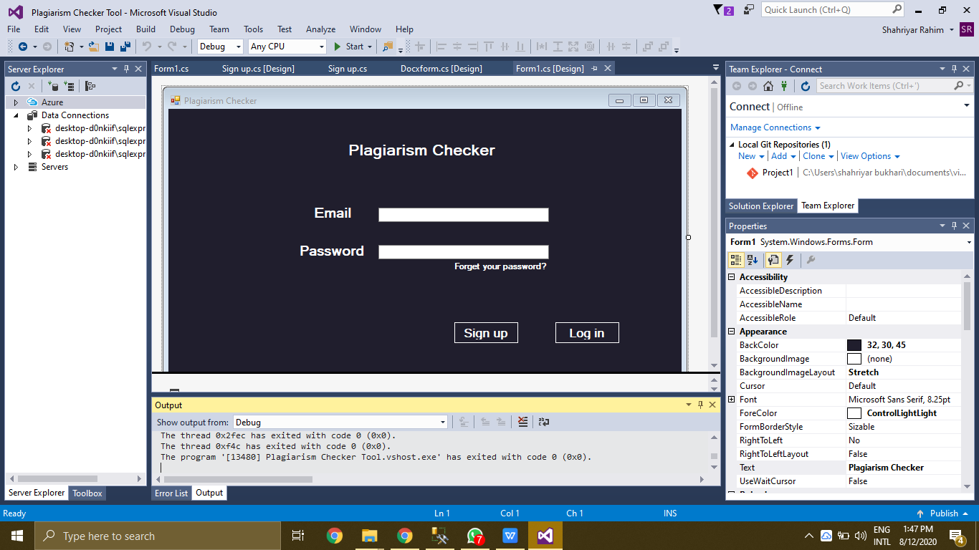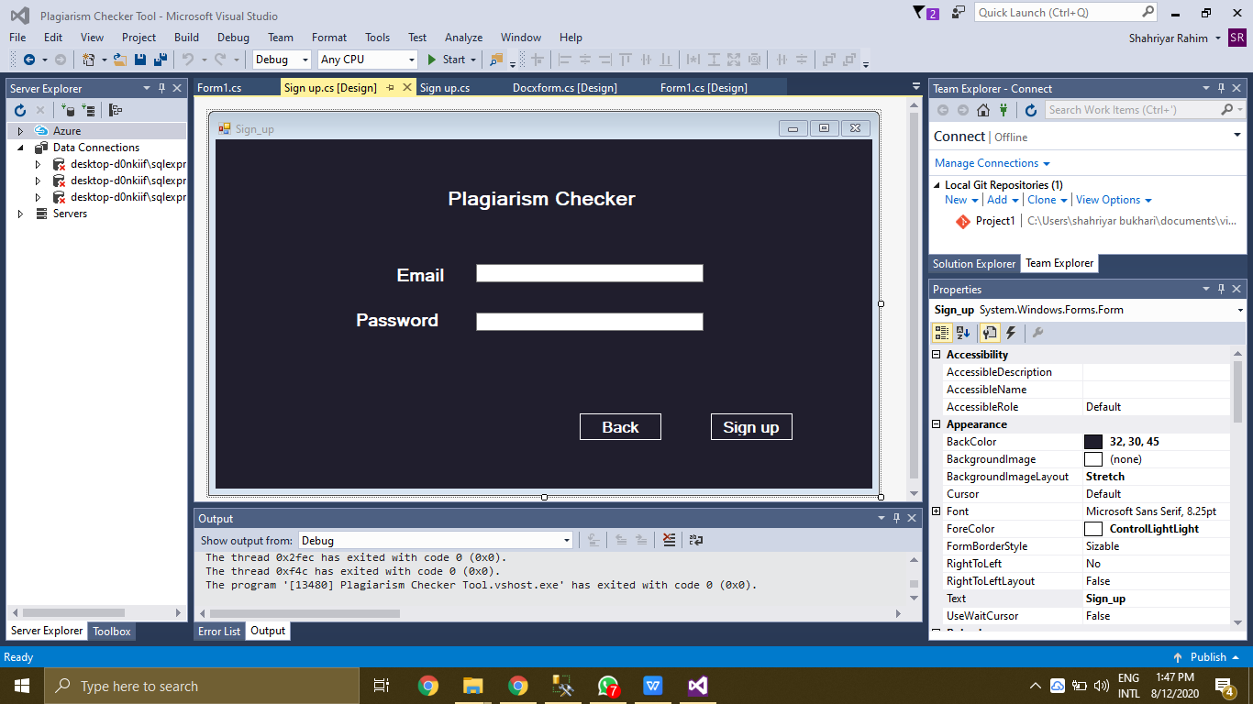

* The Signup and Login form are now worked correctly.We connect the database with these form.Now there is no other objection in this form.Now we add the functionality in both Signup and login form.We made these form secure also.

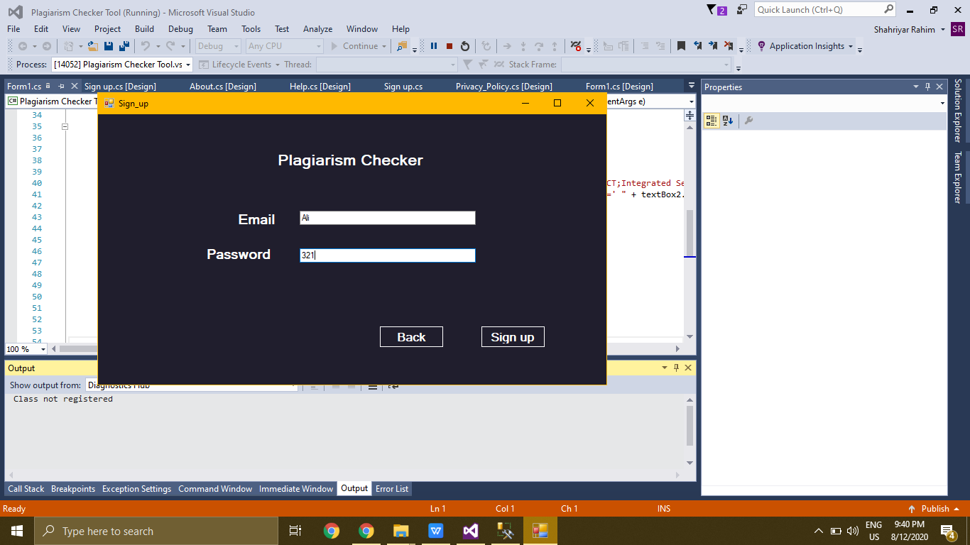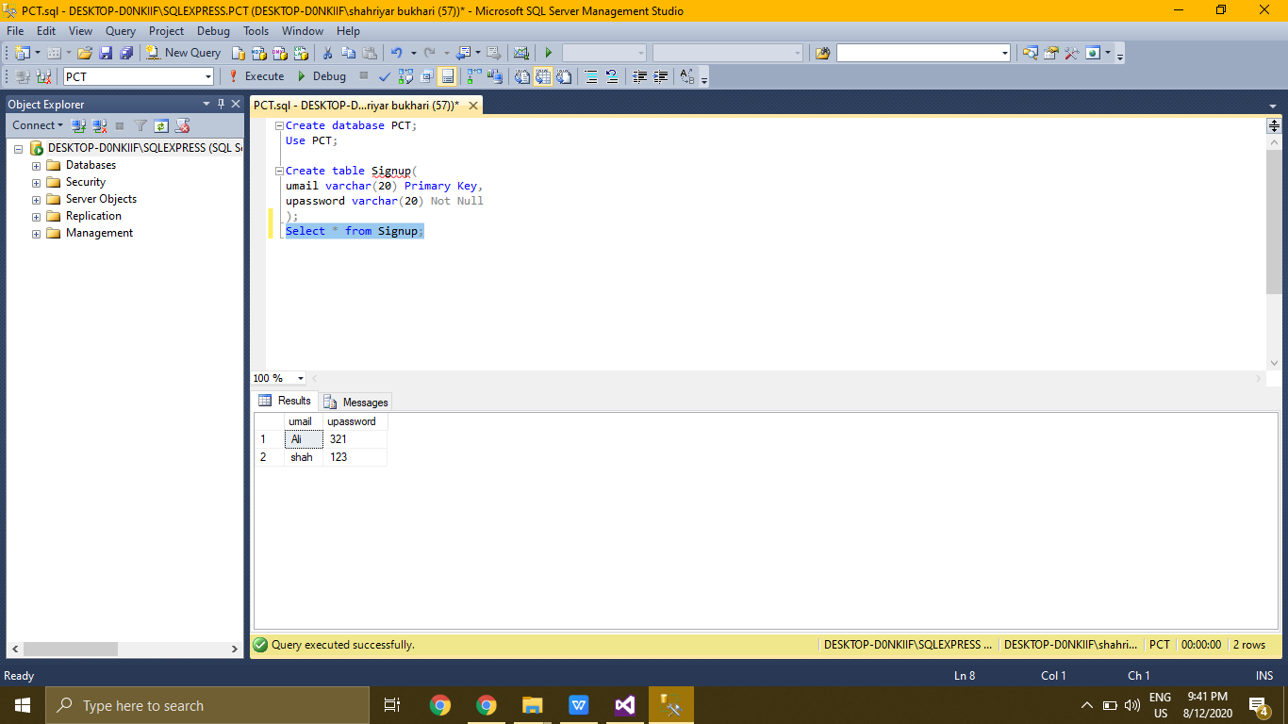

* The size of pages are now user friendly we made all the pages are of same size and there is no other objection in the size of pages.

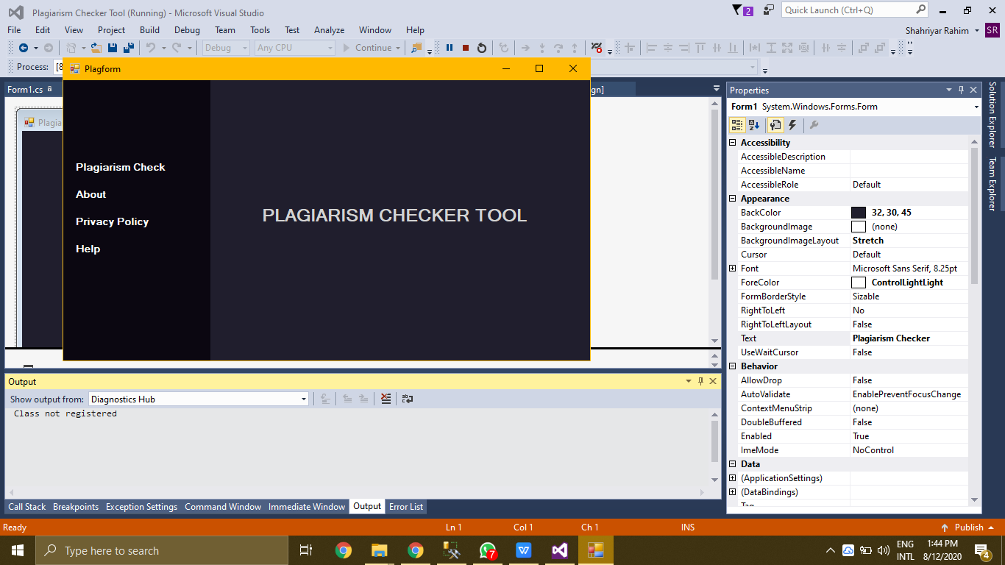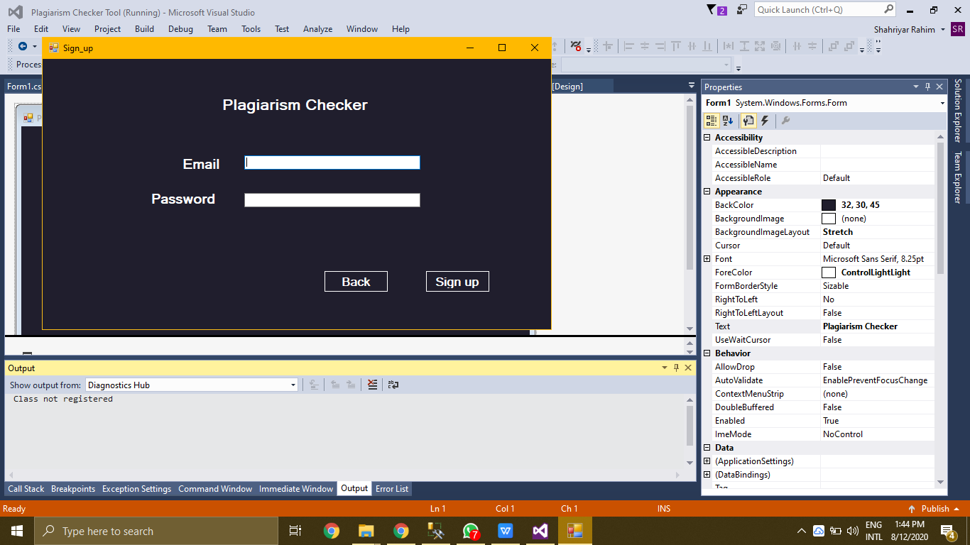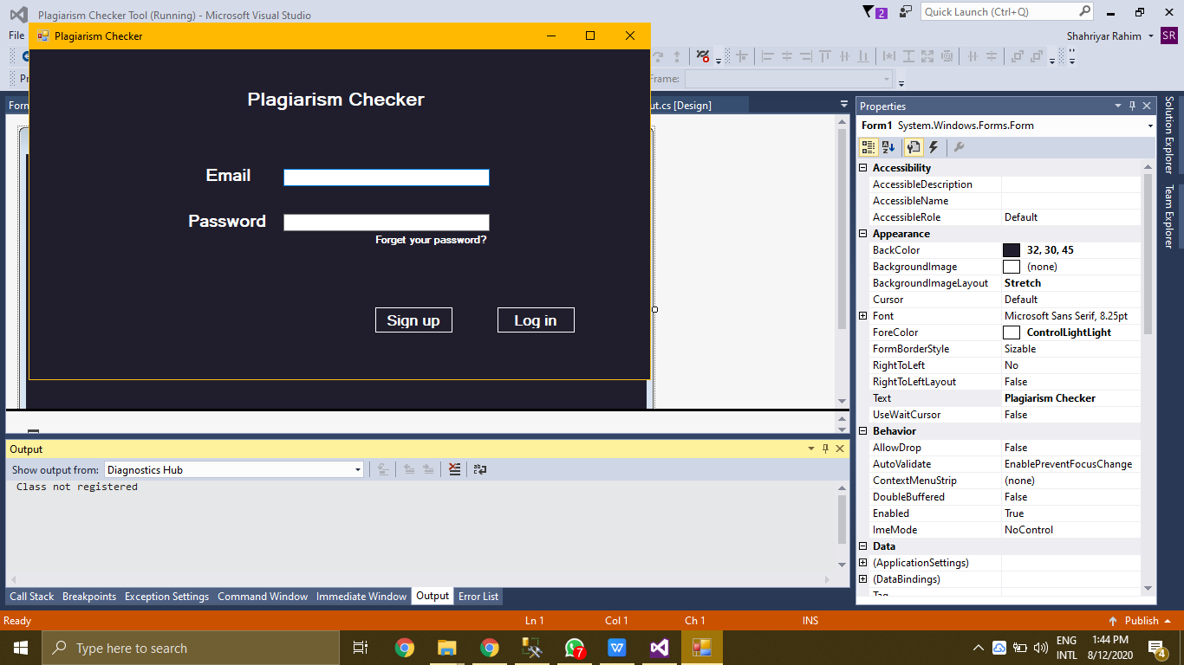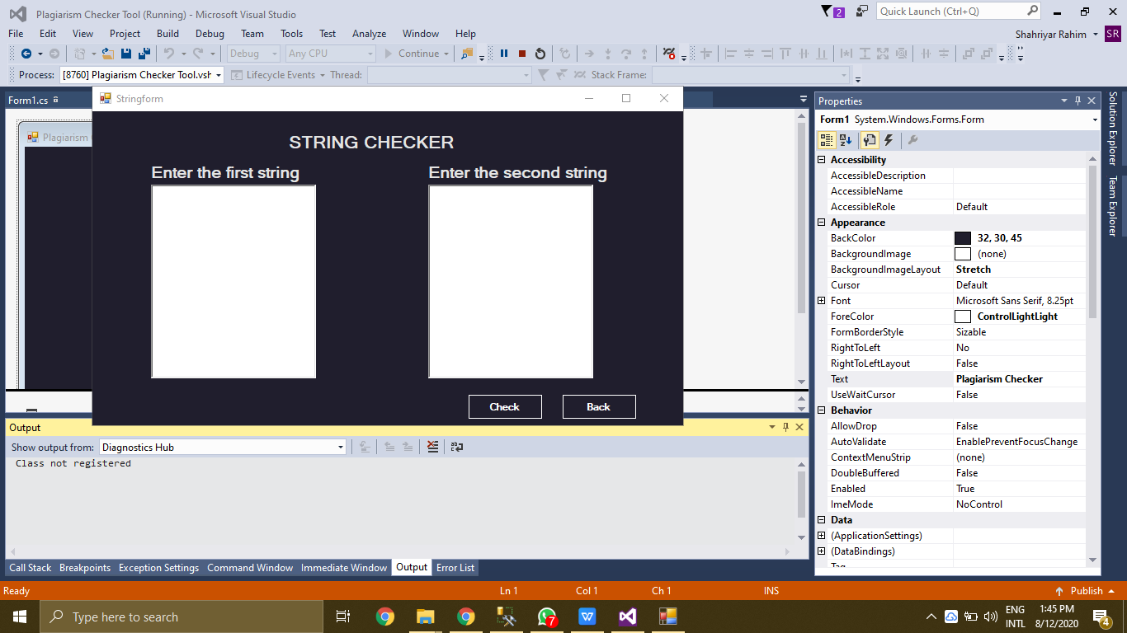

* The Back button are now at the bottom right corner of the page,and there is no other issue in the button also.

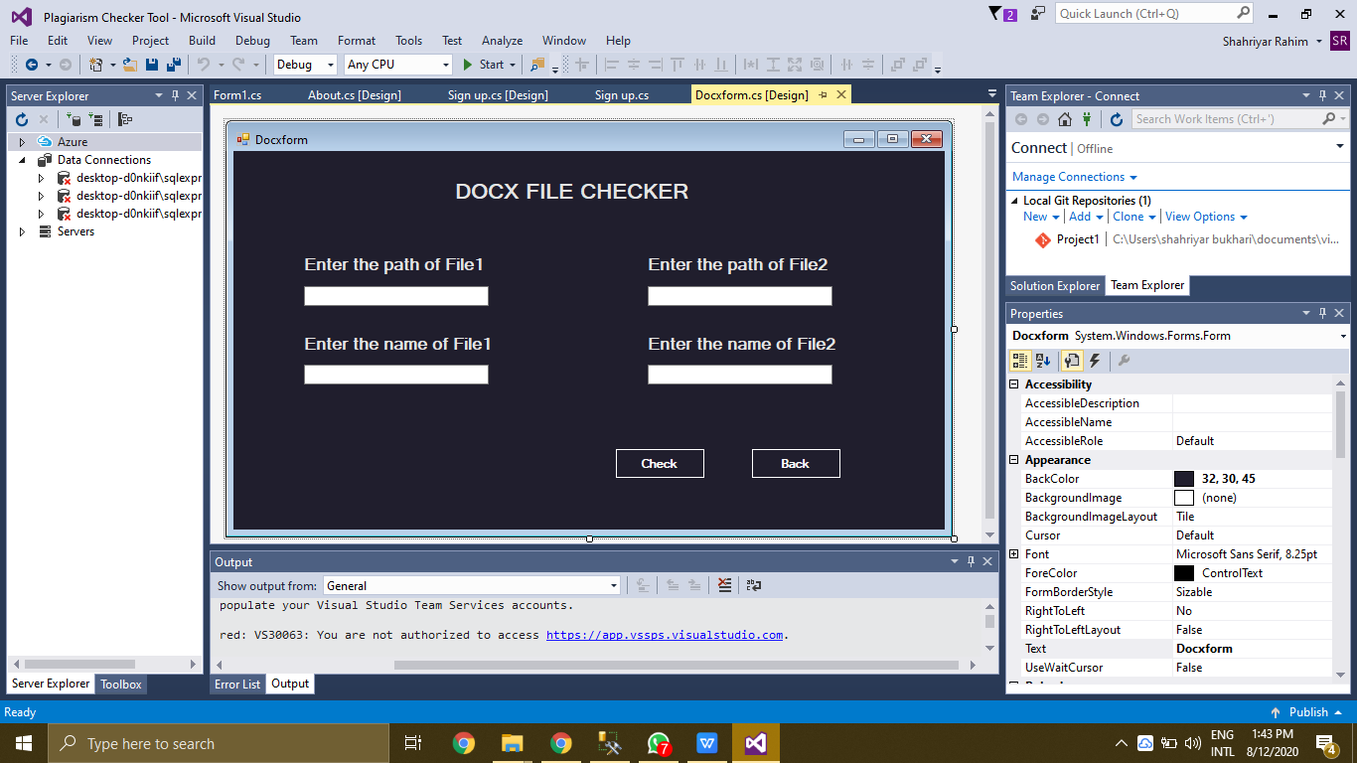

* Now the colors of all the pages are same like that of signup and login form as you can see in above screenshots.

**#2:APPLICATION CRASH ISSUE**

All type of exception are now removed in our project.Now in .cpp and .docx file ,when you enter the path then there is no any error you will face.All the exception and error are now removed.You can easily use the tool with facing error.

**#3:RESULT AND DECREPENCY ISSUE**

We made the tool which check the plagiarism in the sentence by sentence not word by word because there is a lot of words in english sentence are same but the sentence is different at all then hoe we can say that the sentence is plagiarised.

**FOR EXAMPLE:**

First Sentence:My name is Shahriyar.

Second Sentence:My name is Abdullah.

These both of the sentence are different from each other but in this sentence three words will be same.

If the whole sentence in both file are same then our tool shows you hundred percent plagiarism otherwise zero percent plagiarism you will find.

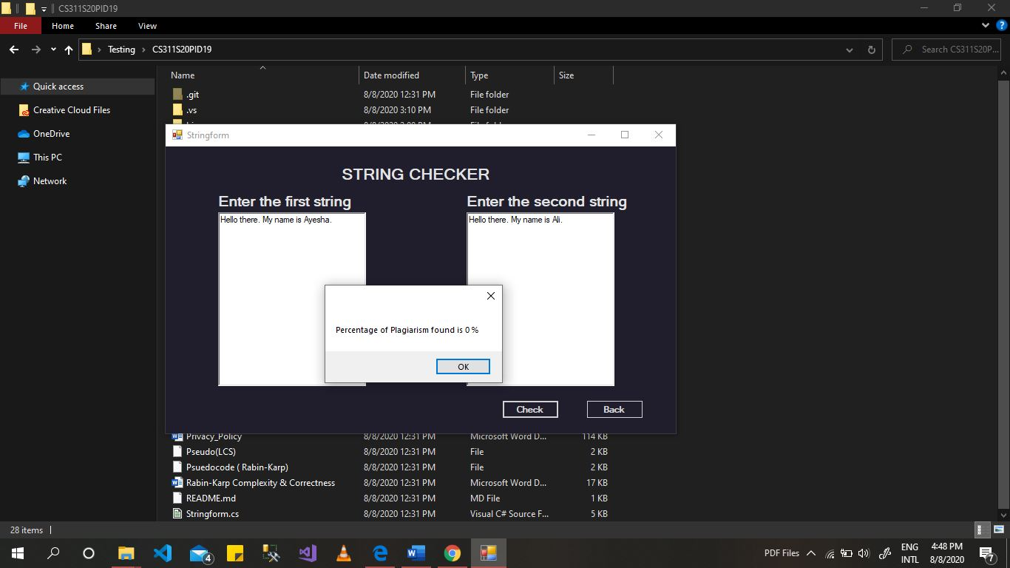

Therefore it is not an issue.It is our plagiarism strategy.

**#4:UI responsiveness issue**

All of the pages are properly show in the tool.Because of some reasons these pages are not show in the tool but now you can see all of the pages in the tool.